# Lab Manual 08

## **Dynamic Routing (RIP)**

Using packet tracer in addressing : 1- We connect the figure .

The cables used are :

* + Straight : between switch, pc and router, switch.
  + Cross : between switch, switch .
  + Serial : betweeen the two routers .

2- We put the IP address for each device as the following :

We have in the figure 5 networks :

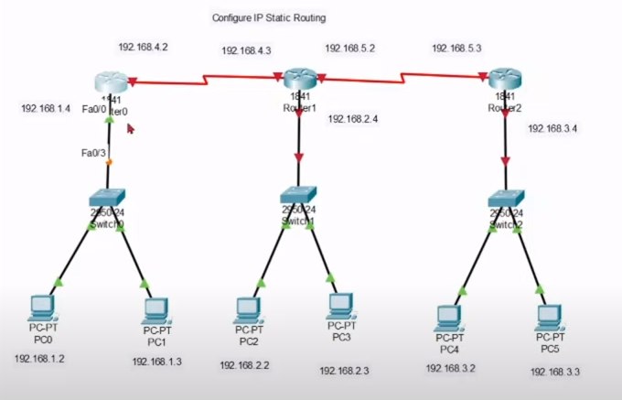

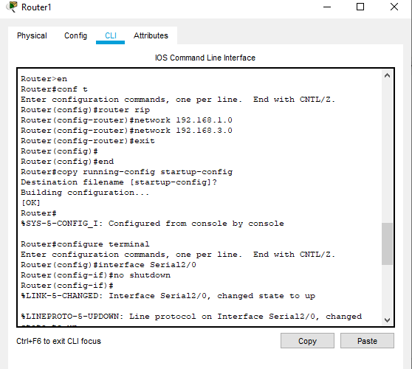

Now, configure RIP on both networks

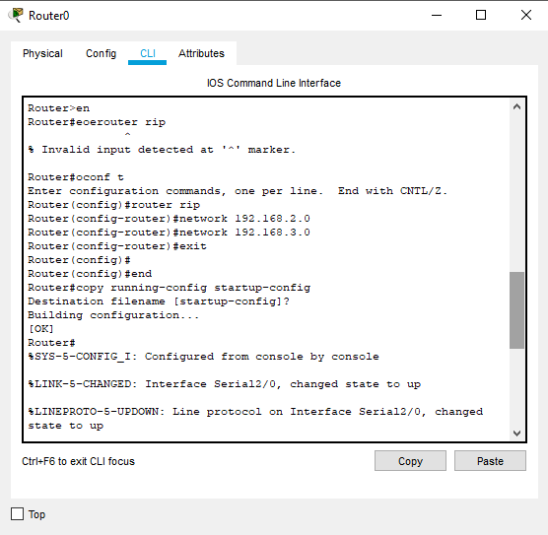

How to ping on default gate way : For PC0

By default RIP will use the route that has low hops counts between source and destination. In our network route1 has low hops counts, so it will be selected. We can use *tracert* command to verify it.

Now suppose route1 is down. We can simulate this situation by removing the cable attached between **Router0**  and **Router2**.

RIP will automatically reroute the traffic. Use ***tracert*** command again to see the magic of dynamic routing.

**Task:**

Configure dynamic routing for the above topology using

**RIP**

* OSPF
* EIGRP

Now ping all the interfaces. Were all the ping’s successful….?